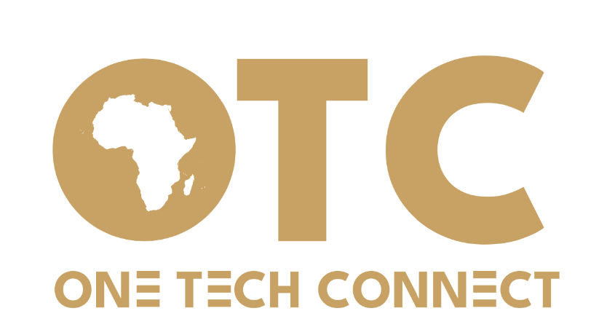

Recommended primary navigation
Home | About Us | OTC Innovation Hub | OTC Academy | OTC Fund | OTC Media | Legal & Business Support Centre | News & Stories | Get in Touch
 | Our Values |  | Research |  |  | Legal
 | Our Team |  | Training |  |  | Business support
 | Our Products
 | Our Innovations
Preferred colors – (Gold, Grey and White and a little sky-blue somewhere)

Home page
Have slides of AI (health robot) digital Agriculture, digital climate solution and art display/performance
Our Impact
2 8 2 1000+
Solutions Developed Organisations supported Campaigns supported Individuals Reached

Five Products (Use visuals to accompany words)
OTC Innovation Hub | OTC Academy | Legal and Business Support Centre | OTC Fund | OTC Media Hub

Our partners (Use logos)
ADIJUST Ministry of Health Personal Data Protection Office Ministry of Science & Innovation

Partner with Us
Subscribe to our Newsletter
Contacts (maintain the current ones)
Footnote (change the current one)
Building Ideas. Creating Solutions. Growing Impact

About Us
Who we are
OTC is a youth-led African innovation organisation harnessing talent, technology, creativity and knowledge to build solutions in Health, SRHR and Sustainable Development.

We turn African ideas into scalable solutions through research, innovation, technical and financial support, business protection and media amplification.

Our Vision

An Africa where young people, ideas and technology drive locally owned solutions that transform communities and shape the future.

Mission
To harness African talent, knowledge, technology and creativity to develop, protect, finance and scale innovative solutions in Health, SRHR and Sustainable Development.

Our Products (provide a drop-down menu for the products below)
Innovation Hub
Academy
Legal and Business Support
OTC Fund
OTC Media

Our Approach
At OTC, we take ideas from opportunity to impact. We discover real problems and opportunities, build innovative solutions and enterprises, protect their intellectual and commercial value, finance their growth with appropriate capital, amplify their stories and connect them to the right audiences, and scale what works to create lasting impact.
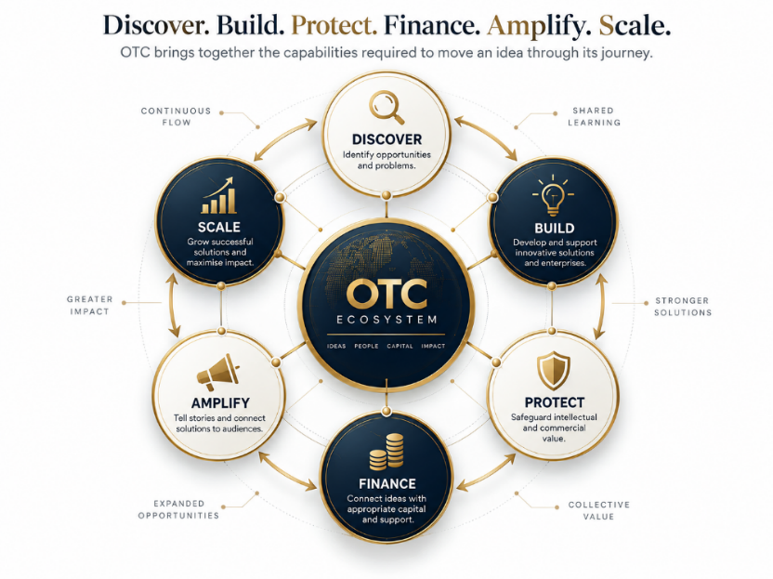

Board Members
Ankunda Patience (provide a placeholder for the photo)
Chairperson, Board of Trustees

Ssekamwa Frank (maintain the current photo)
Executive Member

Kalivayo Blair (maintain the current photo)
Executive Member

Aisha Masimbi (provide a placeholder for the photo)
No-Executive Member

Dr. Stephen Roberts (provide a placeholder for the photo)
No-Executive Member

Our Team
Ssekamwa Frank (maintain the current photo)
Founder & Chief Vision Officer

Kalivayo Blair (maintain the current photo)
Co-Founder & Chief Operations Officer

Achola Tracy (maintain the current photo)
Director of Programmes

Matama Cathy (maintain the current photo)
Co-Founder & Director

Our values

African Agency & Ownership | African people should have the agency, capacity and opportunity to shape, create and own solutions.
Innovation | We embrace creativity, experimentation and better ways of solving real problems.
Integrity | We work with honesty, accountability, transparency and professionalism.
Collaboration | We connect people, institutions, expertise, ideas and resources.
Excellence | We pursue high standards in our products, relationships and delivery.
Sustainability | We design for lasting economic, social and environmental value.
Protection & Fairness | We protect rights, intellectual property, interests and value while promoting fair relationships.
People & Talent | We invest in human potential, knowledge, creativity and leadership.
Impact | We focus on meaningful change that can be demonstrated and sustained.

Our Tech Solutions
WazaziConect
HappyFarma

Explore Opportunities

OTC INNOVATION HUB
Connecting African Innovation. Building Sustainable Solutions.

The OTC Innovation Hub is a pan-African platform for developing, supporting and scaling innovative solutions to Africa's challenges and opportunities.

The Hub aims to develop, connect, empower, and scale African innovation for sustainable development and inclusive growth. We envision to build An Africa where home-grown innovation creates sustainable solutions, connects communities and drives inclusive development.

We bring together innovators, entrepreneurs, researchers, technology developers, businesses, investors and institutions to transform ideas into practical, sustainable and scalable solutions.

We believe in an Africa that does not simply consume innovation, but creates, owns and scales solutions for Africa and the world.

What We Do
IDEATE
We help individuals and organisations identify challenges, explore opportunities and develop innovative ideas.
BUILD
We support innovators to design, prototype, test and refine products, technologies and services.
INCUBATE & ACCELERATE
We provide structured support, mentorship and technical assistance to help promising ideas and ventures move from concept to market.
CONNECT
We connect innovators across Africa with knowledge, talent, markets, investors, institutions and strategic partners.
SCALE
We support promising solutions to expand into new markets, reach more communities and create sustainable impact.

Our Focus
We support innovations that contribute to: Health and Wellbeing; Sexual Reproductive Health; Sustainable development; Youth entrepreneurship; Climate and environmental sustainability; Social and community development.

Connecting Africa's Innovation Ecosystem
OTC builds stronger connections between African innovators, markets, investors, researchers, businesses and institutions, enabling ideas, knowledge, technology and opportunities to move across borders.

Who We Work With
Innovators | Entrepreneurs | Start-ups | Researchers | Students | Technology Developers | Investors | Businesses | Universities | Governments | Development Partners

Our Innovations
WazaziConect
HappyFama

The African Innovation Journey
Problem → Idea → Solution → Enterprise → Scale → Impact
From identifying a challenge to building and scaling a solution, OTC provides an ecosystem of support to help innovators move their ideas forward.

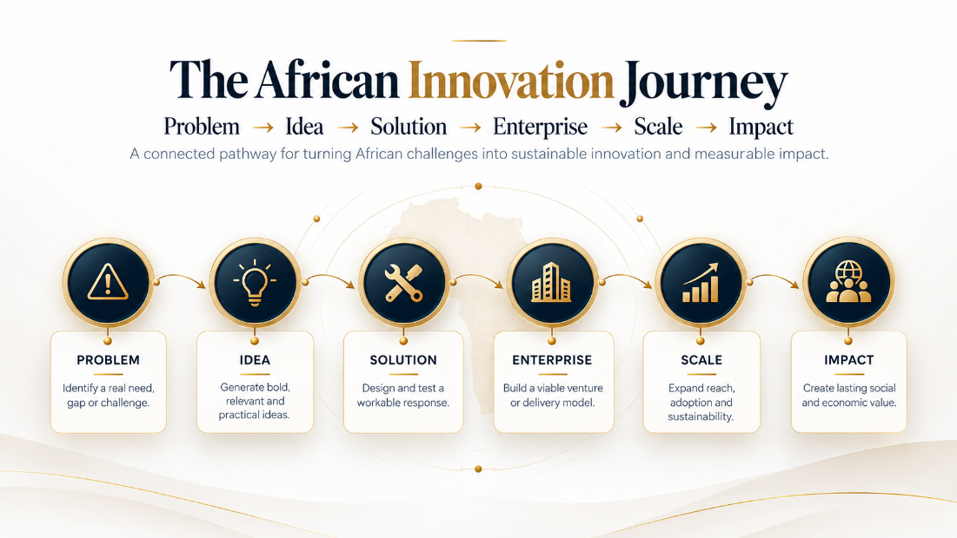

Have an Idea?
Let's build it. Let's connect it. Let's scale it.
Join the OTC Innovation Hub and be part of building sustainable African solutions for Africa and the world.
[Submit Your Idea] [Join the Innovation Hub] [Partner with Us]

OTC ACADEMY
Developing People. Building Capabilities. Shaping Africa’s Future.

OTC Academy is the research, learning and capability-development arm of OTC. It equips individuals, teams and institutions with practical knowledge and skills to innovate, lead, build sustainable enterprises, use technology responsibly and create impact.

Why we exist
Africa’s ideas and enterprises grow when people have the skills, confidence and opportunities to turn knowledge into action. OTC Academy closes that gap through practical, future-facing research and learning tied to real work, enterprise and innovation.

We aim at equipping African individuals and organisations with the evidence, knowledge, skills and capabilities needed to drive innovation, entrepreneurship and sustainable development. We envision an informed, skilled, innovative and empowered Africa equipped to create and shape its own future.

What we do
Undertake innovation research to support evidence-based solutions, learning material and policy interventions.
Design and deliver short courses, masterclasses and executive learning
Run fellowships, leadership programmes and professional development initiatives
Build organisational capability through tailored training and advisory support
Develop practical learning pathways linked to OTC research, innovation and enterprise work

Areas of focus
We work around Innovation and entrepreneurship; Artificial intelligence and emerging technologies; Technology and digital transformation; Business and enterprise development; Leadership and management; Research and innovation; Digital skills; Intellectual property; Data protection, privacy and technology governance; Digital marketing and communications; Investment and financial literacy; Professional and executive education; Fellowships and organisational capacity development

How we work
RESEARCH → LEARN → APPLY → BUILD → LEAD → IMPACT

Explore our Research Centre (clicks and takes to another page)
The OTC Innovation Research Centre is the evidence and intelligence engine of OTC. It studies problems, markets, users, technologies and systems so that decisions, products and investments are grounded in evidence rather than assumption.
Why we exist
Good innovation starts with understanding the problem and continues by testing whether a solution works. The Centre produces the research and evaluation needed to identify opportunities, reduce uncertainty, improve products and understand impact.

What we do
Conduct market, consumer and opportunity research
Support product discovery, user research, usability testing and product-market fit
Undertake feasibility studies, enterprise diagnostics and value-chain analysis
Evaluate products before launch and after deployment
Produce policy, regulatory and technology research
Deliver monitoring, evaluation and learning support
Undertake environmental, social, sustainability and development impact assessments

How we work
RESEARCH → EVIDENCE → INNOVATION → EVALUATION → IMPROVEMENT → IMPACT

Read and Download (Each of the below must take have a provision where we upload research for reading)
Market and opportunity intelligence
Product and innovation research
Product evaluation and impact
Business and enterprise research
AI, automation and emerging technology
Climate, environment, gender and inclusion
Policy and regulatory research
Monitoring, evaluation and learning
Environmental, social and sustainability assessment

Explore of Available trainings
Course/programme catalogue with filters
Upcoming cohort or event cards
Faculty/facilitator profiles where relevant
Application or enquiry form

Our Fellowship Portfolio
Space for current and previous fellowships

Request for Organizational Training – takes to form

Space for testimonials and learning outcomes

OTC FUND
Capital for African Innovation. Protection for African Innovators.

OTC Fund is the capital-mobilisation and enterprise-financing arm of OTC. It seeks to connect promising African innovations, enterprises and creative ventures with appropriate forms of capital while promoting fair, transparent and mutually beneficial relationships.

Why we exist
Capital is often the difference between a promising idea and a viable enterprise. OTC Fund is designed to strengthen investment readiness, improve access to suitable financing and create responsible pathways between innovators and capital.

What we do
Direct Funding | Co-Investing | Fiscal Hosting | Sub-Granting | Investment Readiness | Capital Mobilisation
Mobilise capital for selected initiatives and ventures
Provide or facilitate direct funding where appropriate
Structure co-investment and partnership opportunities
Support fiscal hosting and sub-granting arrangements
Prepare ventures for investment and due diligence
Connect enterprises to investors, grant-makers and financing partners
Support scale financing and capital strategy

Areas of focus
Seed and early-stage innovation
Enterprise growth
Impact and sustainable development
Creative industries
Technology and digital ventures
Research-to-market opportunities
Strategic co-investment and blended financing

How we work
READINESS → MATCH → STRUCTURE → CAPITAL → GROWTH → IMPACT

EXPLORE FUNDING OPPORTUNITIES
Present funding windows only when operational and legally established
Clearly distinguish direct funding, facilitated capital and future funding windows

PARTNER / INVEST WITH OTC

OTC LEGAL & BUSINESS PROTECTION CENTRE
Protecting Innovations. Structuring Opportunity. Enabling Growth.

The OTC Legal & Business Protection Centre helps innovators, entrepreneurs, creative professionals and enterprises protect what they create, structure opportunities properly, manage risk and transact with confidence.

Why we exist
Innovation creates value only when ownership, relationships, compliance and commercial arrangements are clear. The Centre integrates legal, intellectual-property, regulatory and business protection so that growth is built on a sound foundation.

What we do
Advise on intellectual property protection, ownership, licensing and commercialisation
Support company formation, governance, founder arrangements, partnerships and restructuring
Provide transaction, due diligence and M&A support
Advise on tax, licensing, regulatory compliance, data protection and governance
Draft and review contracts and commercial arrangements
Support investment transactions and start-up protection
Protect creative and technology businesses, including software, music, film and digital content

Areas of focus
Patents, trademarks, copyright, designs and trade secrets
IP strategy, licensing and commercialisation
Corporate structuring and governance
Founder and shareholder arrangements
Mergers, acquisitions and due diligence
Tax and revenue advisory
Regulatory, data-protection and technology compliance
Contracts and commercial transactions
Investment and start-up protection
Creative and technology business protection

How we work
DISCOVER → ASSESS → PROTECT → STRUCTURE → COMPLY → TRANSACT → GROW

Protect your idea
Request Business and legal Support (Use an enquiry intake form that routes users by service need)

OTC MEDIA HUB
Creating. Telling. Entertaining. Inspiring.

Campaign Development | Film & Art | Digital and Events (Have these three bars that takes you to separate pages – let the page be interactive like this - https://www.sautiplusmedia.com/about-us )

OTC Media is the creative and storytelling ecosystem of OTC. It develops talent and produces music, film, art, drama, digital content and stories that entertain, inform, connect audiences and amplify African creativity.

Why we exist
Ideas, talent and innovation need strong stories and creative platforms to travel. OTC Media creates space for African voices, develops creative work and helps creators build audiences, protect value and pursue commercial opportunity.

What we do
Produce music, audio, podcasts, video and digital content through OTC Studios
Develop artists, music and creative partnerships through OTC Records
Produce films, documentaries, series and short-form audiovisual work through OTC Films
Support theatre, drama, visual arts, performance and cultural expression
Create social, web and campaign content through OTC Digital
Connect creators to business, legal, distribution and commercialisation support

Areas of focus
Music and audio production
Film and documentary
Podcasts and interviews
Digital content and series
Theatre, drama and visual arts
Artist and creator development
Creative partnerships and campaigns
Distribution, audience growth and commercialization

How we work
CREATE → PRODUCE → CONNECT → BUILD AUDIENCE → COMMERCIALISE → SCALE

How this product connects to OTC
OTC Media amplifies research and innovation across the ecosystem, supports creators with Academy training, protect their work through the Legal & Business Protection Centre, connect promising creative ventures to the Fund and tell the stories of OTC products and impact.

Developer notes
Rich multimedia layout
Featured releases/productions
Creator or artist profiles where appropriate
Embedded audio/video capability
Commission, collaboration and talent-submission enquiries

Bars above
Campaign Development (we have one product here)
Data Justice Champions Campaign
We partnered with ADIJUST, designed and ran the Data Justice Champions Campaign which sought to use art and digital media to enhance responsible personal data handling among young Ugandans with a focus on the youths.

We designed the campaign strategy that involved recruitment and scruitnesation of content creators, and a tiktok challenge.

Over 200,000 youths engaged on TikTok and other social media during the one month’s campaign.

Over 30 youths were skilled about digital health rights and justice in Katanga slum in Uganda.

Over 10+ TikTokers and content creators were recruited and capacitated about responsible data handling.

This is project was supported by the ADIJUST in partnership with the University of Warwick and the Personal Data Protection Office with generous support from the Wellcome Trust

Film & Art
Coming soon

Digital & Events
Coming Soon

Primary calls to action
CREATE WITH OTC

EXPLORE OTC MEDIA

